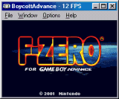
BoycottAdvance is a reasonably good Gameboy Advance emulator. Though one major complaint until recently was that it didn't support sound, but as of version 0.21b this has been fixed.
BoycottAdvance is cardware. This means the only thing you have to do to register is send the author a postcard from where you live. If you register you will receive the latest beta's with the latest features. For more information, visit the author's homepage.
You can also find translations of BoycottAdvance on the author's homepage for many languages, including about every major Asian language. Futhermore it has ports for other systems such as Macintosh, Linux and BeOS.

